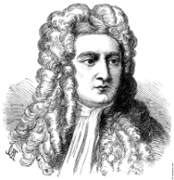
Scientific Revolution Trading Cards
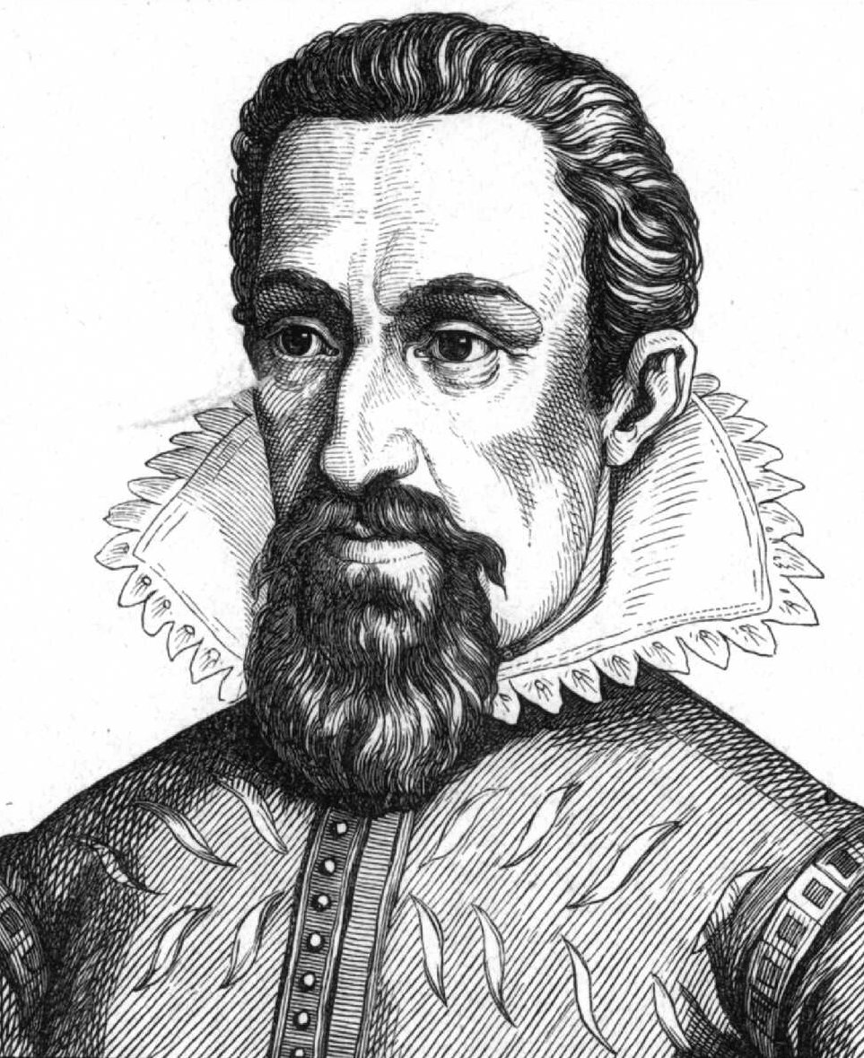
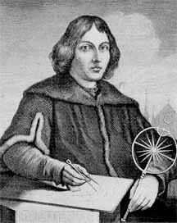
Create a set of trading cards representing the major achievements of the names of the Scientifc Revolution
Newton

  - Nicolaus Copernicus
  - Rene Descartes
  - Isaac Newton
Copernicus
  - Galileo Galilei
Kepler
  - Johannes Kepler
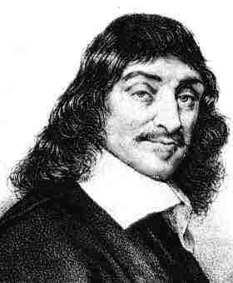
  - Francis Bacon
  - Robert Boyle
- On the Front include
  - Their picture
  - Name
Descartes
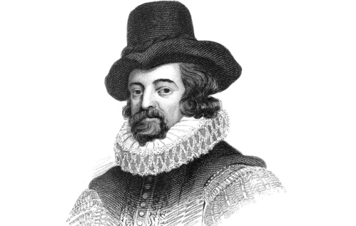
  - And decorated to represent their ideas
- On the Back include:
  - Biographical info
  - Major Achievements/Ideas
  - Any Published material
Bacon
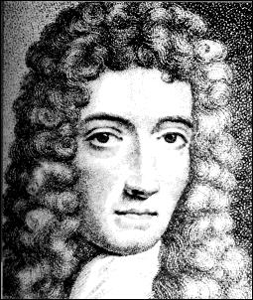
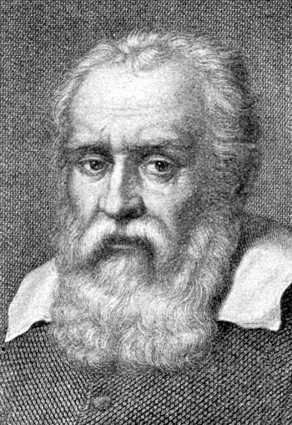
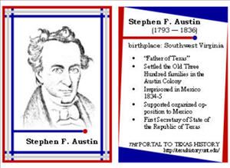
Example:
Boyle
Galileo

