Activity 5.3.2: Technology of the Age of Exploration 5/18/2011
Purpose: Students will learn how early explorers used technology and compare to modern technology
Standard: SSWH10 (c) Explain the role of improved technology in European exploration; include the astrolabe
Directions: Students will look at the website to research several instruments used in navigation. http://www.seattleartmuseum.org/exhibit/interactives/spain/launchWin.htm
Technology | How and Why it was used
Quadrant
Astrolabe
Sextant/Octant
Chronometer

Writing Prompt: Which instrument would you choose if you were to sail across an ocean? Why?
______________________________________________________________________________________________________________________________________________________________________________________________________________________________________________________________________________________________________
Make your instrument: Chose one of the instruments below and construct your own out of the materials provided
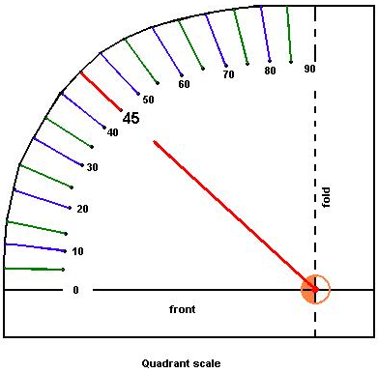
What to do
- Glue the scale onto particle-board (like the back of a note pad) & cut the board down to the shape of the scale (outer perimeter only)
- Glue the FOLDED edge (dashed line) onto your meterstick, a little less than the distance from the "0" end as your arm is long (so you can reach it while holding the "0" end up to your eye)
- Glue one end of a 30 cm. (1ft) long string to the orange circle & tie a weight to the other end of the string
***For and Astrolabe ask Coach to print out “ Make Your Own Astrolabe” or Download it from Coach’s Websites***

